**Name:Yugendran K M**

**Reg no:1919103713**

**Assignment-I**

To create with piezo alarm, PIR sensor, temp sensor with below functionalities;

1. Alarm should sound in one manner if temp is above 60 C
2. Alarm should sound with another frequency if motion is detected in PIR sensor.

**Circuit connection:**

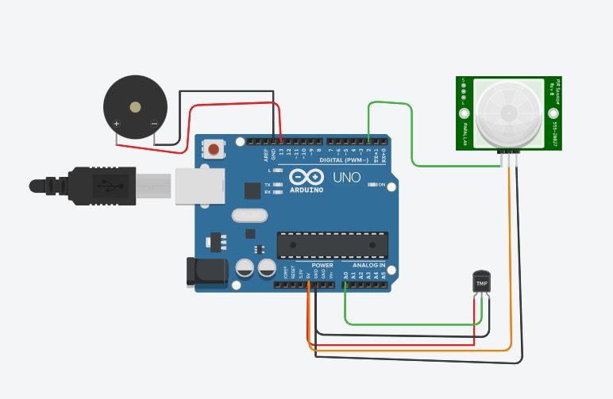

**Code:**

void setup()

{

Serial.begin(9600);

pinMode(A0,INPUT);

pinMode(2,INPUT);

pinMode(13,OUTPUT);

}

void loop()

{

double data=analogRead(A0);

double n=(data/1024);

double volt=n*5;

double off=volt-0.5;

double temp=off*100;

Serial.print("temperature= ");

Serial.println(temp);

int pir=digitalRead(2);

Serial.print("motion= ");

Serial.println("Object decected");

if(temp>60){

tone(13,100);

delay(5000);

noTone(13);

}

if(pir==1){

tone(13,200);

delay(5000);

noTone(13);

}

}

**Output:**

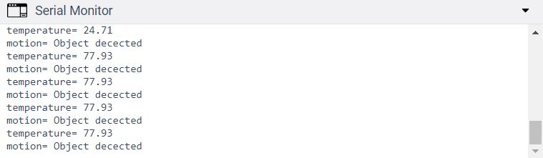

**Working Circuit Design:**

